# JavaDoc Conclusions

JavaDoc was a simple enough plugin to use as Eclipse already has it implemented. I researched how to implement it into my code and how to generate the JavaDoc document.

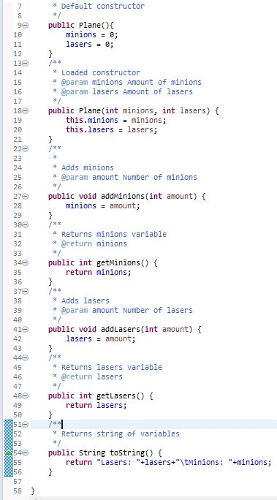Using the ‘/**’ line and pressing enter would autogenerate the section of comments with the ‘@param’ and ‘@return’ headings which I could fill in and then display on the JavaDoc page.

Figure 1. Spaceship class with JavaDoc comments

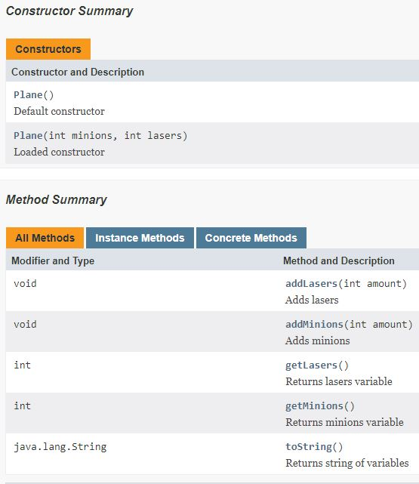JavaDoc html page with methods listed including constructors and get and set methods. All with descriptions of parameters and return values.